**MS Projects:**

**Chapter 1: Microsoft Project Introduction:**

**Basics:**

1. **Resources**: The profile that is needed to perform a particular task. For Testing we will need Test analysts, Testers, Test Leads, Subject Matter Experts etc So these are all regarded as resources.
2. **Allocation:** is defining the resources for a particular task
3. **Scheduling:** is the estimation of duration for a particular task. Estimating comes along with experience. The more the experience the better the estimation.
4. **Predecessor:** in general, means the task preceding. In simple terms you can say the task that is coming before a particular task.
5. **Successor:** means the task that is next to the present one.
6. **Gantt chart:** is a series of horizontal lines that shows the amount of work done. In a nut shell it is a chart or a graph representing overall progress along with specific dependencies.
7. **Critical Task:** is the longest duration in milestones.

**Menu Bar:**

The tabs consisting of File, Task, Resource, Report, Project etc are all menu bars in a MS Project tool.

Screen shot of the same is provided below:

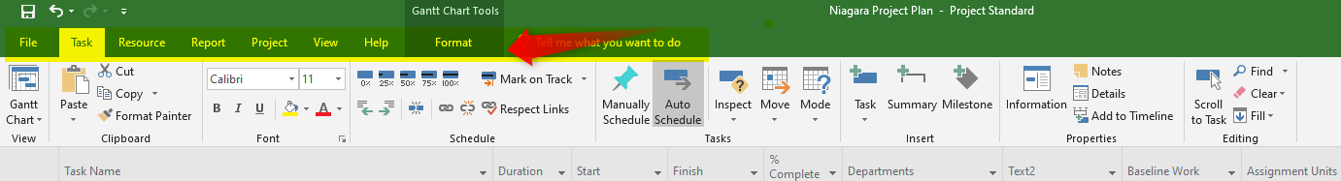

In File there are multiple options & these are represented as New, Open, Save, Saveas , Print etc.

Refer the below screen shot for more details.

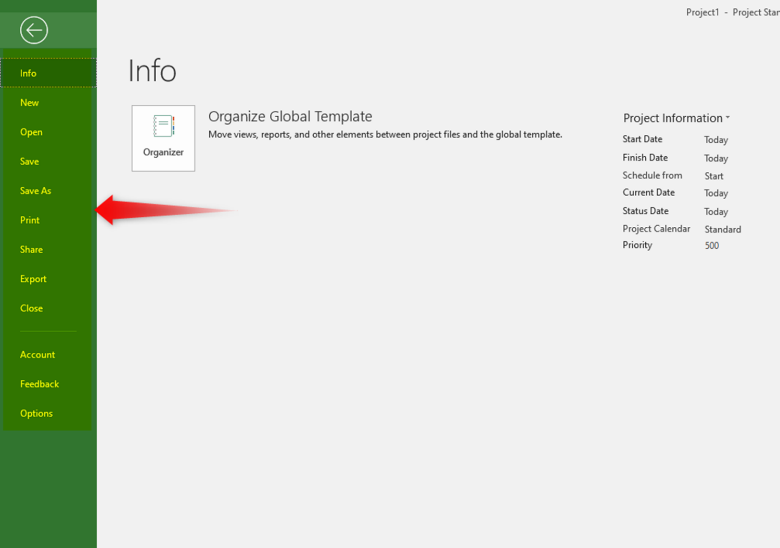

Like this all options for each tab can be explored as to what tabs & buttons are available.

**Chapter 2: Task Creation**

How to create a Task?

There are three ways to create a task:

1st way: Just go to the particular cell in the column Task name & enter the task name. Here the user has entered as A

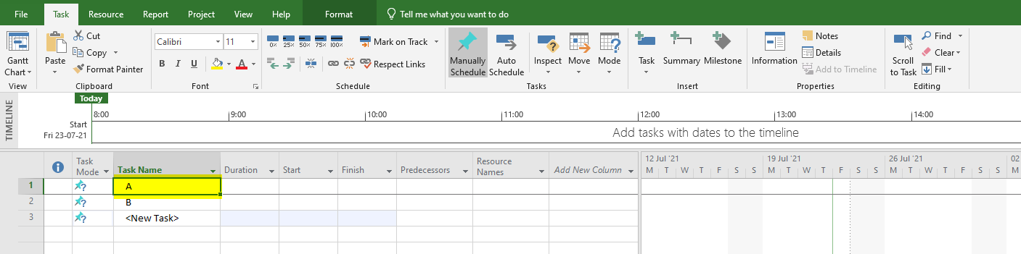

2nd way: The other way is to go & to Menu bar & in drop down of Task. Click Task as highlighted in the screen

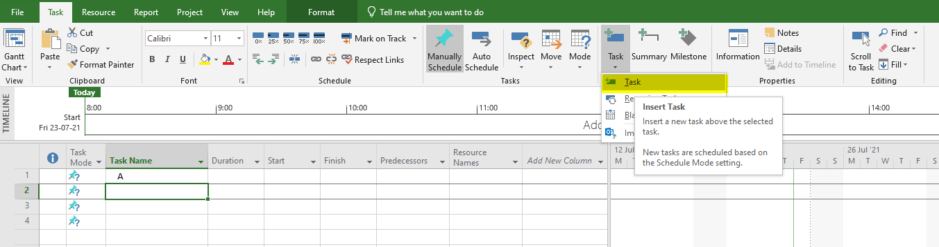

You will get this output when the user clicks Task button in the drop down. On the cell the notification displayed will be <New task>

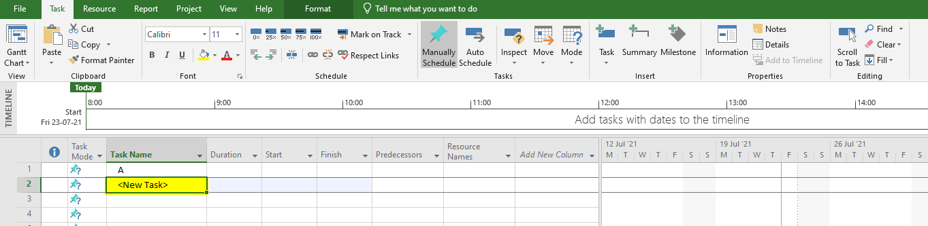

3rd way: the final way is to directly click on the Task button for creating a task.

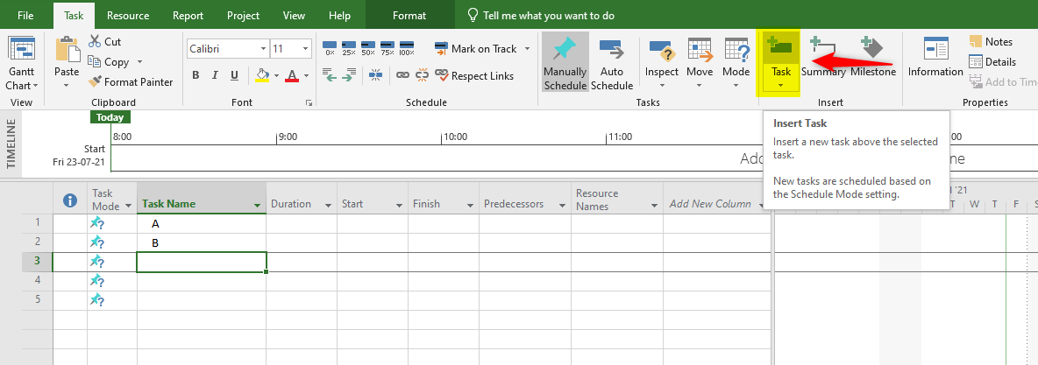

Next if the user explores there are several columns in MS projects.

Now if you go to Task mode there are two options:

* Manually scheduled
* Auto scheduled

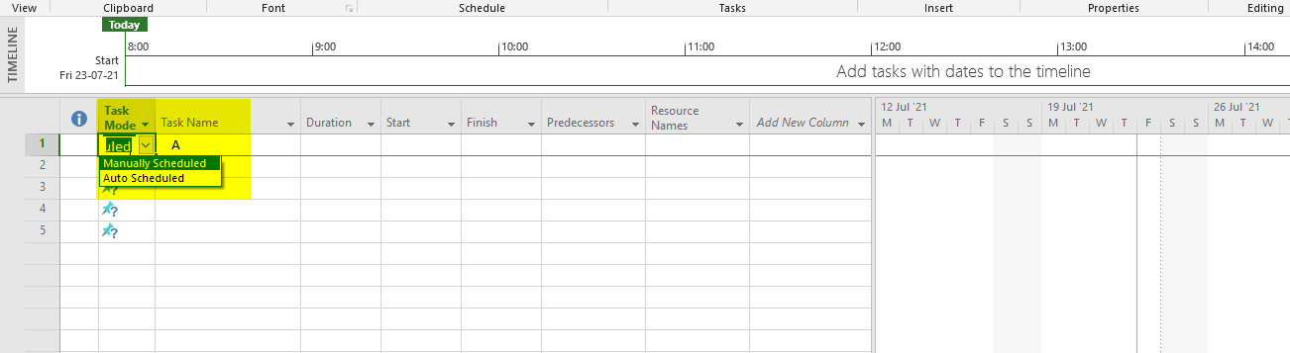

* **Auto scheduled:** If you click on Auto scheduled then dates for start & finish are mentioned with today’s date.

Also the duration has 1 day by default with a “?”. Now the user can mentioned his respective days .

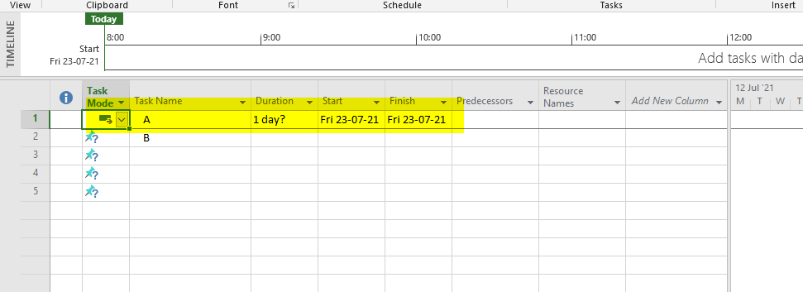

* **Manually scheduled:** If Manually scheduled option is chosen then the start date, finish date & duration is not updated by default. The user has to update these details.

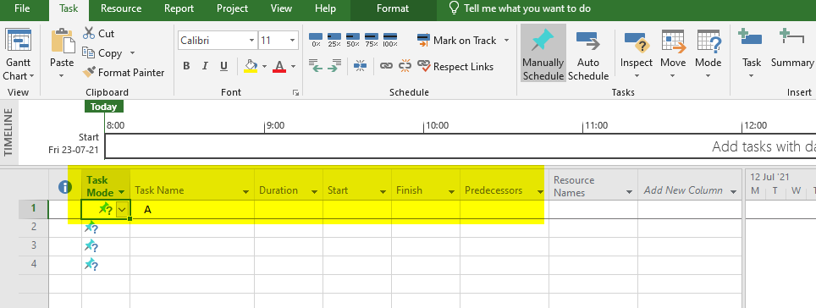

**Chapter 3: Predecessor:**

The concept of processor work on row number given in predecessor cell. The MS Projects tool takes the next date from the finish date of predecessor given.

1.Suppose a plan to clean & start the car. In the below example already, the dates & plan for opening the door & cleaning the car is given

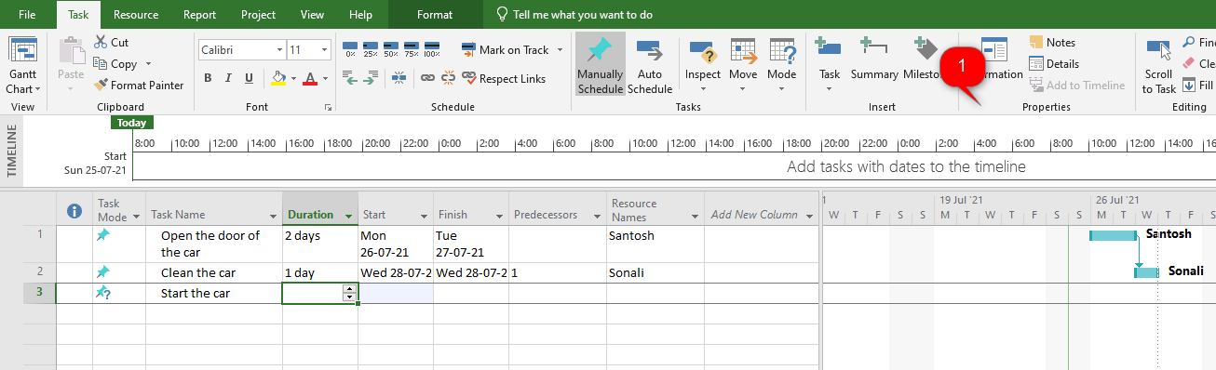

2.The next step is to start the car but in above screen shot if the user refers then he needs to start the car in such a way that days should not clash & should happen subsequently post cleaning the car.

In that way the user is expecting 2 days for starting the car. So he will enter 2 days but as you see the dates are not captured. Refer below screen shot.

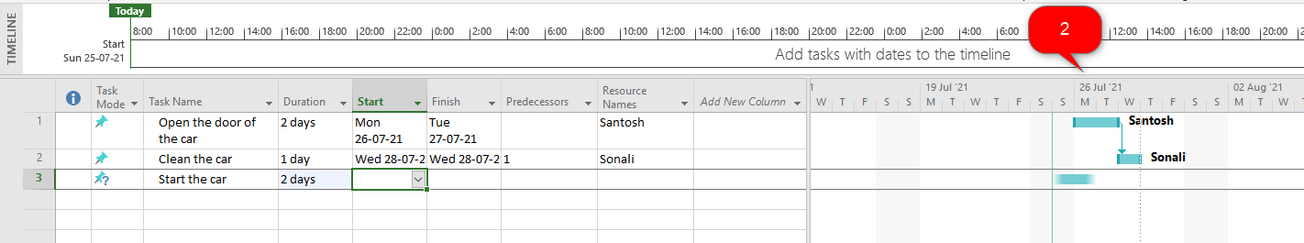

3. The plan here is to ensure that tasks flow in such a manner that dates do not clash. In order to ensure this the user has to enter the row number 2 in predecessor cell. Then automatically the dates capture after the task of cleaning the car which is row number 2.

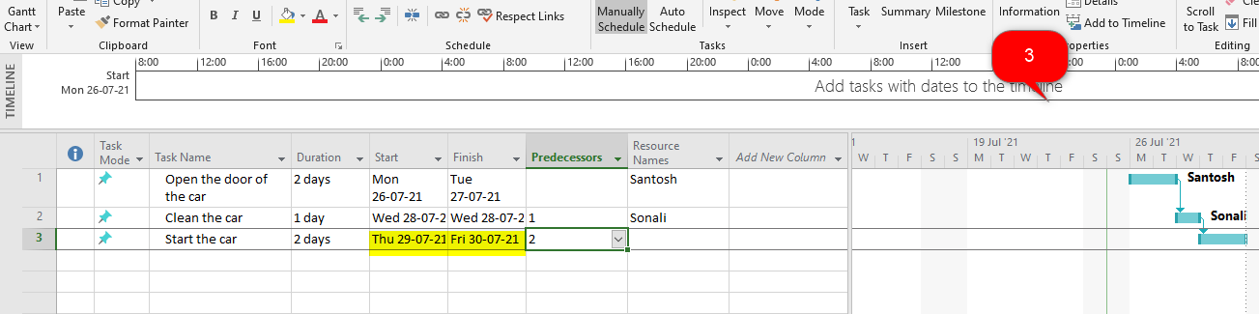

4. The user has entered the responsibility is for Ashwini. Then this is also depicted in Gantt chart as highlighted in below screen shot.

